.

### MINI PROJECT REPORT

**On**

**WEB-READ**

**B.E (IT) – IV Sem**

**By**

#### Karthik Reddy Pesaru (1601-19-737-039)

**Mohammed Fawwazuddin (1601-19-737-041)**

**Under the guidance of**

**Smt. T. Satya Kiranmai**

**Assistant Professor**



**DEPARTMENT OF INFORMATION TECHNOLOGY CHAITANYA BHARATHI INSTITUTE OF TECHNOLOGY (A)**

**(Affiliated to Osmania University; Accredited by NBA(AICTE) and NAAC(UGC), ISO Certified 9001:2015)**

#### KOKAPET(V), GANDIPET(M), RR District HYDERABAD 75

**Website:** [**www.cbit.ac.in**](http://www.cbit.ac.in/)

**2021-2022**





**CERTIFICATE**

This is to certify that the project work entitled “ **WEB-READ** ” submitted to CHAITANYA BHARATHI INSTITUTE OF TECHNOLOGY, in partial fulfillment of the requirements for the award of the completion of IV semester of B.E in Information Technology, during the academic year 2021-2022, is a record of original work done by **Karthik Reddy Pesaru (1601-19-737-039), Mohammed Fawwazuddin (1601-19-737-041)** during the period of study in Department of IT, CBIT, HYDERABAD, under our guidance.

#### Project Guide Head of the Department

#### Smt. T. Satya Kiranmai Dr. K. Radhika

Assistant Professor, Dept. of IT, Professor, Dept. of IT,

CBIT, Hyderabad. CBIT, Hyderabad.

## ACKNOWLEDGEMENT

We would like to express our heartfelt gratitude to Smt. T. Satya Kiranmai Ma’am, our project guide, for her invaluable guidance and constant support, along with her capable instruction and persistent encouragement.

We are grateful to our Head of Department, Dr. K. Radhika, for her steady support and for the provision of every resource required for the completion of this project.

We would like to take this opportunity to thank our Principal, Prof. G. P. S. Varma Sir, as well as the management of the institute, for having designed an excellent learning atmosphere.

Our thanks are due to all member of the staff and our lab assistants for providing me with the help required to carry out the groundwork of this project.

#### ABSTRACT

This project consists of the development of a contributory web for Writers & Readers. The goal of this application is to create a platform which enables the Writers & Readers to create, share and peruse the data inventory. It is meant to open the possibilities to share and read at the convenience of one’s resources.

The website is meant to make publication made available in [digital](https://en.wikipedia.org/wiki/Digital_data) form, consisting of text, images, or both, readable on the [flat-panel display](https://en.wikipedia.org/wiki/Flat-panel_display) of computers or other electronic devices. Although sometimes defined as "an electronic version of a printed book", some e-books exist without a printed equivalent. E-books can be read on dedicated [e-reader](https://en.wikipedia.org/wiki/E-reader) devices, but also on any computer device that features a controllable viewing screen, including [desktop computers](https://en.wikipedia.org/wiki/Desktop_computer), [laptops](https://en.wikipedia.org/wiki/Laptop), [tablets](https://en.wikipedia.org/wiki/Tablet_computer) and [smartphones](https://en.wikipedia.org/wiki/Smartphone).

With e-books, users can browse through titles online and can download the e-book. With the use of **GetForm.io**, users will be able to share their writings by filling out the form which will be stored at **GetForm.io** database, which enables to review and host the writings of users and viewers.

The web application employs easy-to-use, relatively inexpensive, services together, such as HTML, CSS, and JavaScript programming languages. To enable the ability to host the website at free of cost, the site will be using the **(.netlify.app)** extension along with it.

**CONTENTS**

|  |  |  |
| --- | --- | --- |
| **S.no** | **Topics** | **Page. No** |
|  | **Certificate** | ii |
|  | **Acknowledgement** | iii |
|  | **Abstract** | iv |
|  | **Contents** | v |
|  | **List of screenshots** | vi |
| **1** | **Introduction**   * 1. Motivation   2. Objective of the project   3. Problem statement |  |
|  | 7 |
|  | 7  7 |
| **2** | **Project Requirements**  2.1 Software Requirements  2.2 Hardware Requirements |  |
|  | 8 |
|  | 8 |
|  |  |
| **3** | **Implementation of Project**  3.1 Main Homepage    3.2 Author’s Page    3.3 Dark-Mode |  |
|  | 9 |
|  | 9 |
|  | 9 |
|  |  |
| **4** | **Code & Implementation**   * 1. HTML Implementation   2. CSS Implementation   3. Results (Screenshots) |  |
|  | 10 |
|  | 16  26 |
| **5** | **Conclusion & Future scope** | 39 |
|  | **Bibliography** | 40 |

**LIST OF SCREENSHOTS**:

|  |  |  |
| --- | --- | --- |
| **SCREENSHOT** | **DESCRIPTION** | **PAGE NO** |
| 4.1 | WEB-READ HOME PAGE (1/2) | 26 |
| 4.2 | WEB-READ HOME PAGE (2/2) | 27 |
| 4.3 | AUTHOR’S BOOK- I | 27 |
| 4.4 | AUTHOR’S BOOK- II | 28 |
| 4.5 | AUTHOR’S PAGE – LIGHT MODE | 29 |
| 4.6 | AUTHOR’S PAGE – **DARK** MODE | 30 |
| 4.7 | AUTHOR’S PAGE – LIGHT MODE | 31 |
| 4.8 | AUTHOR’S PAGE – **DARK** MODE | 32 |
| 4.9 | **IOS** DEVICE | 33, 34 |
| 4.10 | **ANDROID** DEVICE | 35, 36 |
| 4.11 | **IOS** DEVICE | 37, 38 |

**INTRODUCTION**

**1.1 Motivation**

Web development is difficult to learn, especially when you are first getting started. It is easy to get stuck on a problem and end up quitting. Many people go through this cycle several times before they can harness the motivation to see it through to the end. Even more people never get the far.

I went through this cycle myself during the lockdown period and transformed me from someone who had an overview of web-development languages like HTML, CSS, JAVASCRIPT into a web-developer who has successfully deployed & hosted many websites, intended for a cause to use new techniques, and learn to adapt to new outcomes.

**1.2 Objective of the Project**

Our main objective for this project is to bring together the community, intended for Writers and Readers, which consists of the development of a website for the objective of this project is to design a platform which enables the Writers & Readers to create, share and peruse the data inventory.

It is meant to open the possibilities to share and read at the convenience of one’s resources. The website is meant to make publication made available in [digital](https://en.wikipedia.org/wiki/Digital_data) form, consisting of text, images, or both, readable on the [flat-panel display](https://en.wikipedia.org/wiki/Flat-panel_display) of computers or other electronic devices.

**1.3 Project Statement**

**“A platform for Writers & Readers to create, share and peruse the data inventory.”**

**PROJECT REQUIREMENTS**

**2.1 Software Requirements**

**Web-Read** website is compatible with across all the electronic devices. With the implementation of screen-responsive support, the website can handle both the Mobile and PC operating systems.

The development of website is built using Microsoft Visual Studio Code.

For the convenience and easy-to-learn and easy-to-deploy, Netlify, a San Francisco-based cloud computing company, offers hosting and serverless backend services for web applications and static websites at free of cost for beginners. It offers basic computing storage and offers free security for sites.

**2.2 Hardware Requirements**

**Web-Read** website is compatible with all most all the electronic devices. With the new technologies, it is now possible for any electronic device with suitable processing speed to host and deploy our website for faster results.

**IMPLEMENTATION OF PROJECT**

Our Project firstly Consists of Main Homepage which includes the direct access to our respective authors identities, easily and conveniently, with beautiful interface and with built-in features.

With the use of **GetForm.io**, users will be able to share their writings by filling out the form which will be stored at **GetForm.io** database, which enables to review and host the writings of users and viewers.

The web application employs easy-to-use, relatively inexpensive, services together, such as HTML, CSS, and JavaScript programming languages. To enable the ability to host the website at free of cost, the site will be using the **(.netlify.app)** extension along with it.

**3.1 MAIN HOMEPAGE** consists of HTML code, embedded with CSS stylesheet. Homepage is the first landing site whenever a user clicks on the URL (<https://web-read.netlify.app/>), prompting the user to homepage.

Homepage is designed by using HTML & CSS which, when executed, displays the beautiful and gorgeous website. It is faster in deploying, thanks to the CSS works. Homepage lets a user to scroll and move freely. The user is free to let use and let read from the authors of his/her likes.

Homepage features the all-new “**FEATURE YOUR WRITINGS**”, which lets the new talented writers to share their writings with the Web-Read team, to make it visible to the readers. Thanks to **GetForm.io**, the talented writers will be able to share their writings with the team by filling out the form, which will be stored at **GetForm.io** database, which enables the team to review and host the writings of users, viewers, and readers.

**3.2 AUTHOR’S PAGE** consists of main HTML code, embedded with CSS stylesheet. Author’s page is the second interaction in the website, with respect to the authors.

Readers will be able to interact with the Author’s profile and the works published by the authors. Our website gives the reader the ability to peruse the works at free of cost and one’s convenience. With the profile of author comes with their respective social media handles, which makes the readers to connect easily and peruse the other publications by them.

**3.3 DARK-MODE** feature is provided for all the webpages except for the Main Homepage. Dark Mode gives the readers to read anywhere and anytime, without straining eyes.

**CODE & IMPLEMENTATION**

**4.1 *HTML: - a)* HOME PAGE**

<!DOCTYPE html>

<html>

<head>

    <link rel="icon" type="image/png" sizes="16x16" href="images/favicon-16x16.png">

    <meta charset="UTF-8">

    <meta name="viewport" content="width=device-width, initial-scale=1.0">

    <title>Web-Read</title>

    <link rel="stylesheet" type="text/css" href="css/shayar.css">

    <link rel="stylesheet" type="text/css" href="css/style.css">

    <link rel="stylesheet" type="text/css" href="css/mobile.css" media="screen and (max-width : 568px)">

</head>

<body>

    <div id="body">

        <div id="featured">

            <img src="images/bookshelf2.jpg" alt="">

            <div>

                <h2>WELCOME TO <br>

                WEB-READ</h2>

                <br />

                <br />

                <br />

                <br />

                <span>BOOKS,POEMS & POETRIES</span>

                <br />

                <br />

                <span>BY THE STUDENTS OF CBIT.</span>

                <br />

                <a href="portfolio.html" class="more">About Us</a>

            </div>

        </div>

        <br />

        <h2><b> AUTHORS & POETS</b></h2>

        <br />

        <br />

        <ul>

            <li>

                <a href="maheen.html">

                    <img src="images/maheen.jpg" alt="">

                    <span>Maheen Sadiq</span>

                </a>

            </li>

            <li>

                <a href="ruth.html">

                    <img src="images/ruth.jpeg" alt="">

                    <span>Ruth Sharon</span>

                </a>

            </li>

        </ul>

        <ul>

            <hr class="works">

            <br />

            <br />

            <br />

            <br />

            <li>

                <a href="https://risbii.netlify.app/">

                    <img src="images/fawwaz.jpeg" alt="">

                    <span>Mohammed Fawwaz</span>

                </a>

            </li>

            <li>

                <a href="raoof.html">

                    <img src="images/raoofimg.jpeg" alt="">

                    <span>Ahmed Raoofuddin</span>

                </a>

            </li>

            <li>

                <a href="bilal.html">

                    <img src="images/bilal.jpeg" alt="">

                    <span>Mohammed Bilal</span>

                </a>

            </li>

            <li>

                <br />

                <a href="adnan-shayari.html">

                    <img src="images/adnan.jpeg" alt="">

                    <span>Mohammed Adnan</span>

                </a>

            </li>

            <li>

                <br />

                <a href="shoieb.html">

                    <img src="images/shoieb.jpeg" alt="">

                    <span>Shoieb Ur Rahman</span>

                </a>

            </li>

            <li>

                <br />

                <a href="susheel.html">

                    <img src="images/susheel.jpeg" alt="">

                    <span>Susheel Kumar</span>

                </a>

                <br />

                <br />

            </li>

            <br />

        </ul>

        <hr class="workd">

    </div>

    <div id="body">

        <br />

        <br />

        <br />

        <h1><span>FEATURE YOUR WRITINGS</span></h1>

        <br />

        <br />

        <br />

        <form action="https://getform.io/f/c1bb52b0-f72c-451b-aa72-128ce028c289" method="POST">

            <input type="text" name="fname" id="fname" placeholder="Name">

            <input type="text" name="media" id="smedia" placeholder="Instragram Id">

            <input type="text" name="media" id="smedia" placeholder="Snapchat Id">

            <input type="text" name="media" id="smedia" placeholder="Linkedin Id">

            <input type="text" name="media" id="smedia" placeholder="Email Id">

            <textarea name="message" id="message" placeholder="Your Writings"></textarea>

            <input type="submit" name="send" id="send" value="send">

        </form>

    </div>

    <div id="footer">

        <div>

            <p>&copy; <b>2021 by Md Fawwaz & Karthik Reddy. All rights reserved.</b></p>

        </div>

    </div>

</body>

</html>

**4.1 *HTML*: - b*)* AUTHOR’S PROFILE**

 . . . . .

<body>

              <section id="portfolio" class="content">

                       <br />

                <i  class="fa fa-moon-o" onclick="myFunction()" style="font-size:42px"></i>

                <br />

                <br />

                <div class="big">

                    <p>Click for Dark-Mode.</p>

                    </div>

                    <br />

                  <h2> <b>MAHEEN SADIQ</b></h2>

                  <div class="big">

                    <div class="image-cropper" >

                    <img src="images/maheen.jpg" alt="" class="profile-pic">

                    </div>

                    </div>

                    <br />

                    <div class="big">

                      <p><b>Refresh Once.</b></p>

                      </div>

                      <br />

                  <p>Engineering major seeking to use research and writing experience in the role of a student. I believe my fast learning abilities, commitment to succeed, and relevant studies make me the perfect fit for this position. Awarded multiple honors based on merits and expected to graduate with a B.E from CBIT in June of 2023.

                <br />

                <br />

                <br />

                <div class="big">

                    <p><b>Branch : </b> CIVIL</p>

                    </div>

                </p>

                  </section>

                    <footer>

                        <ul class="social">

                            <li><a href="mailto:ugs19010_civil.maheen@cbit.org.in" target="_blank" alt="Gmail"><i class="fa fa-google" style="font-size:37px"></i></a></li>

                            <li><a href="https://instagram.com/maheensadiq._?igshid=1gesl2sez3it3/" target="_blank" alt="Instagram"><i class="fa fa-instagram" style="font-size:37px"></i></a></li>

                            <li><a href="https://www.linkedin.com/in/m-s-472b99200/" target="_blank" alt="Linkedin"><i class="fa fa-linkedin" style="font-size:37px"></i></a></li>

                            <li><a href="https://www.snapchat.com/add/maaheeennnn " target="_blank" alt="Snapchat"><i class="fa fa-snapchat" style="font-size:37px"></i></a></li>

                        </ul>

                    </footer>

          </body>

<hr />

<section id="about" class="content">

    <div class="poem">

      <section id="portfolio" class="content">

      <h1> <b>MAHEEN'S POEMS </b></h1>

      <ul>

        <li><b>Breathe.</b></li>

        <br />

          <li>Breathe, let it go</li>

          <li>Let a new dawn</li>

          <br />

          <li>Bring the fresh hopes</li>

          <li>And even if it does not</li>

          <br />

          <li>You are still breathing</li>

          <li>For a new tomorrow</li>

      </ul>

      <hr class="works">

      </div>

  </div>

    </section>

    <footer>

      <ul class="social">

          <br />

          &copy; <b> WEB-READ &trade;</b> 2021

      </ul>

  </footer>

</body>

</body>

</html>

**4.2 *CSS: -* a*)* HOMEPAGE + AUTHOR’S PAGE**

@font-face {

    font-family: 'poller_oneregular';

    src: url('../fonts/pollerone/pollerone-webfont.eot');

    src: url('../fonts/pollerone/pollerone-webfont.eot?#iefix') format('embedded-opentype'),

         url('../fonts/pollerone/pollerone-webfont.woff') format('woff'),

         url('../fonts/pollerone/pollerone-webfont.ttf') format('truetype'),

         url('../fonts/pollerone/pollerone-webfont.svg#poller_oneregular') format('svg');

}

@font-face {

    font-family: 'leckerli_oneregular';

    src: url('../fonts/leckerlione/leckerlione-regular-webfont.eot');

    src: url('../fonts/leckerlione/leckerlione-regular-webfont.eot?#iefix') format('embedded-opentype'),

         url('../fonts/leckerlione/leckerlione-regular-webfont.woff') format('woff'),

         url('../fonts/leckerlione/leckerlione-regular-webfont.ttf') format('truetype'),

         url('../fonts/leckerlione/leckerlione-regular-webfont.svg#leckerli_oneregular') format('svg');

}

body {

    background: #fff;

    font-family: Arial, Helvetica, sans-serif;

    font-size: 14px;

    font-weight: normal;

    line-height: 1;

    margin: 0;

    min-width: 960px;

    padding: 0;

}

p {

    color: #252525;

    line-height: 24px;

    margin: 0;

    padding: 0;

}

p a {

    color: #252525;

    text-decoration: underline;

}

p a:hover {

    color: #898989;

}

#header {

    background-color: burlywood;

    margin: 0 auto;

    padding: 44px 0 50px;

    text-align: center;

    width: 960px;

}

#header a.logo {

    display: block;

    margin: 0 auto;

    padding: 0;

    width: 340px;

}

#header a.logo img {

    border: 0;

    display: block;

    margin: 0;

    padding: 0;

}

#header ul {

    margin: 0;

    padding: 56px 0 0;

}

#header ul li {

    display: inline;

    list-style: none;

    margin: 0;

    padding: 0 19px;

}

#header ul li a {

    color: #252525;

    display: inline-block;

    font-family: "Arial Black", Gadget, sans-serif;

    font-size: 25px;

    font-weight: normal;

    margin: 0;

    padding: 0 0 3px;

    text-decoration: none;

    text-transform: uppercase;

}

#header ul li a:hover, #header ul li.selected a {

    color: #0ba39c;

}

#body {

    margin: 0;

    padding: 0 0 30px;

    text-align: center;

}

#body h1 {

    color: #fff;

    display: inline;

    font-family: poller_oneregular;

    font-size: 35px;

    font-weight: normal;

    margin: 0;

    padding: 0;

    text-transform: uppercase;

}

#body h1 span {

    background: #252525;

    display:inline;

    padding: 15px 28px 12px;

}

#body > div {

    margin: 0 auto;

    padding: 0;

    width: 960px;

}

#body > div img {

    border: 2px solid #292929;

    margin: 12px 0 0;

    align-content: center;

    padding: 0;

}

#body div ul {

    margin: 0;

    padding: 24px 10px 0;

    width: 940px;

}

#body div ul li {

    border: 2px solid #1a1a1a;

    display: block;

    list-style: none;

    margin: 0 0 13px;

    overflow: hidden;

    padding: 0;

}

#body div ul li .figure {

    border-right: 2px solid #1a1a1a;

    float: left;

    margin: 0;

    padding: 0;

    width: 376px;

}

#body div ul li img {

    border: 0;

    display: block;

    margin: 50;

    align-content: space-between;

    padding: 0;

    opacity: 0.8;

    transition: 0.5s ease-in-out;

}

#body div ul li .figure:hover img {

    opacity: 1;

}

#body div ul li div {

    float: left;

    margin: 0;

    padding: 63px 0 20px;

    width: 558px;

}

#body div ul li div h3 {

    color: #252525;

    font-family: "Arial Black", Gadget, sans-serif;

    font-size: 25px;

    font-weight: normal;

    margin: 0;

    padding: 0;

    text-transform: uppercase;

}

#body div ul li div p {

    padding: 30px 30px 18px;

}

#body div ul li div a.more {

    background: #000;

    color: #fff;

    display: inline-block;

    font-family: "Arial Black", Gadget, sans-serif;

    font-size: 18px;

    font-weight: normal;

    margin: 0;

    padding: 8px 28px;

    text-decoration: none;

    text-transform: uppercase;

}

#body div ul li div a.more:hover {

    color: #252525;

    background: #fff;

    border: 2px solid #252525;

}

#body #featured {

    margin: 0 0 13px;

    padding: 0;

    position: relative;

    width: 100%;

}

#body #featured img {

    border-radius: 3px;

    display: block;

    align-content: space-between;

    margin: 0;

    padding: 0;

    width: 100%;

}

#body #featured div {

    left: 50%;

    margin-left: -480px;

    margin-top: -171px;

    padding: 0 0 0 470px;

    position: absolute;

    top: 50%;

    text-align: left;

    width: 490px;

}

#body #featured div h2 {

    background: rgb(255, 255, 255);

    color: rgb(0, 0, 0);

    display:inline-block;

    border-radius: 5px;

    text-align: center;

    align-items: center;

    font-family: poller_oneregular;

    font-size: 60px;

    left: inherit;

    font-weight: normal;

    margin: 0 0 18px;

    padding: 23px 27px 20px;

    text-transform: uppercase;

}

#body #featured div span {

    background: rgb(0, 0, 0);

    color:rgb(255, 246, 163);

    text-align: center;

    border-radius: 8px;

    font-family: poller_oneregular;

    display: block;

    display:flex;

    font-size: 20px;

    margin: 7px 0;

    padding: 12px 27px;

}

#body #featured div a {

    background: #0ba39c;

    border-radius: 3px;

    color: #fff;

    display: inline-block;

    font-size: 16px;

    margin: 15px 0 0;

    padding: 26px 27px 22px;

    align-content: center;

    align-items: center;

    text-align: center;

    text-decoration: none;

    text-transform: uppercase;

}

#body #featured div a:hover {

    background: #1fc3bc;

}

#body > ul {

    margin: 0 auto;

    overflow: hidden;

    padding: 24px 0 0;

    width: 960px;

}

#body > ul li {

    display: block;

    float: left;

    margin: 0 10px 20px;

    padding: 0;

    width: 299px;

}

#body > ul li a {

    color: #000;

    display: block;

    font-family: poller_oneregular;

    font-size: 20px;

    font-weight: normal;

    margin: 0;

    padding: 0;

    text-align: center;

    text-decoration: none;

    text-transform: uppercase;

}

#body > ul li a img {

    border-radius: 10%;

    border: 2px solid #1a1a1a;

    display: inline-block;

    align-content: space-between;

    margin: 50;

    padding: 30;

    opacity: .8;

    transition: 0.5s ease-in-out;

}

#body > ul li a:hover img {

    opacity: 1;

}

#body > ul li a span {

    display: block;

    align-items: center;

    align-content: center;

    margin: 0;

    padding: 33px 0 0;

}

#body form {

    margin: 0 auto;

    padding: 24px 0 0;

    width: 620px;

}

#body form input, #body form textarea {

    border: 2px solid #252525;

    color: #252525;

    font-family: Arial, Helvetica, sans-serif;

    font-size: 15px;

    font-weight: normal;

    margin: 0 0 37px;

    padding: 20px 10px;

    text-align: center;

    text-transform: uppercase;

    width: 596px;

    border-radius: 8px;

}

#body form textarea {

    height: 175px;

    overflow: auto;

    resize: none;

}

#body form #send {

    background: #252525;

    color: #fff;

    font-family: "Arial Black", Gadget, sans-serif;

    font-size: 15px;

    font-weight: normal;

    display: inline-block;

    padding: 20px 28px;

    width: auto;

}

#body form #send:hover {

    background: #fff;

    color: #252525;

    cursor: pointer;

}

#footer {

    background: #252525;

    margin: 0;

    padding: 36px 0 42px;

}

#footer div {

    margin: 0 auto;

    overflow: hidden;

    padding: 0;

    width: 960px;

}

#footer div p {

    color: #fff;

    float: right;

    line-height: 66px;

    margin: 0 0 0 10px;

    padding: 0;

}

#footer div ul {

    display: block;

    float: right;

    margin: 0;

    overflow: hidden;

    padding: 0;

    width: 256px;

}

#footer div ul li {

    display: block;

    float: left;

    list-style: none;

    margin: 0 10px;

    padding: 0;

    width: 44px;

}

hr.works {

    border: 2px solid rgb(173, 13, 13);

    border-radius: 5px;

  }hr.workd {

    border: 2px solid rgb(179, 73, 12);

    border-radius: 5px;

  }

**4.2 *CSS: -* *b)* AUTHOR’S PAGE + DARK MODE**

.imag {

    display: block;

    margin-left: auto;

    margin-right: auto;

    width: 48%;

}

.lot {

    text-align: center;

}

.btn btn-outline-info btn-lg {

    position: absolute;

    top: 50%;

}

.change {

    border-radius: 50%;

    display: flex;

    flex-direction: column;

    justify-content: center;

    align-items: center;

}

.poem li:first-child::first-letter

{

  font-size:60px;

  text-underline-position: below;

  text-underline-offset:inherit;

  font-style:italic;

  padding-right:3px;

  text-align: left;

}

.poem li:not(:first-child)

{

  margin-left: 33px;

}

.poem li

{

  font-family:Times New Roman;

  font-style:italic;

  padding-bottom: 0.1em;

  font-size: 21px;

  text-align: left;

}

.poem ul, .poem ol

{

    list-style-type: none;

}

body {

    padding: 25px;

    background-color: white;

    color: black;

    font-size: 25px;

  }

  .dark-mode {

    background-color: rgb(17, 17, 17);

    color: white;

**4.3 WEB-READ SCREENSHOTS**

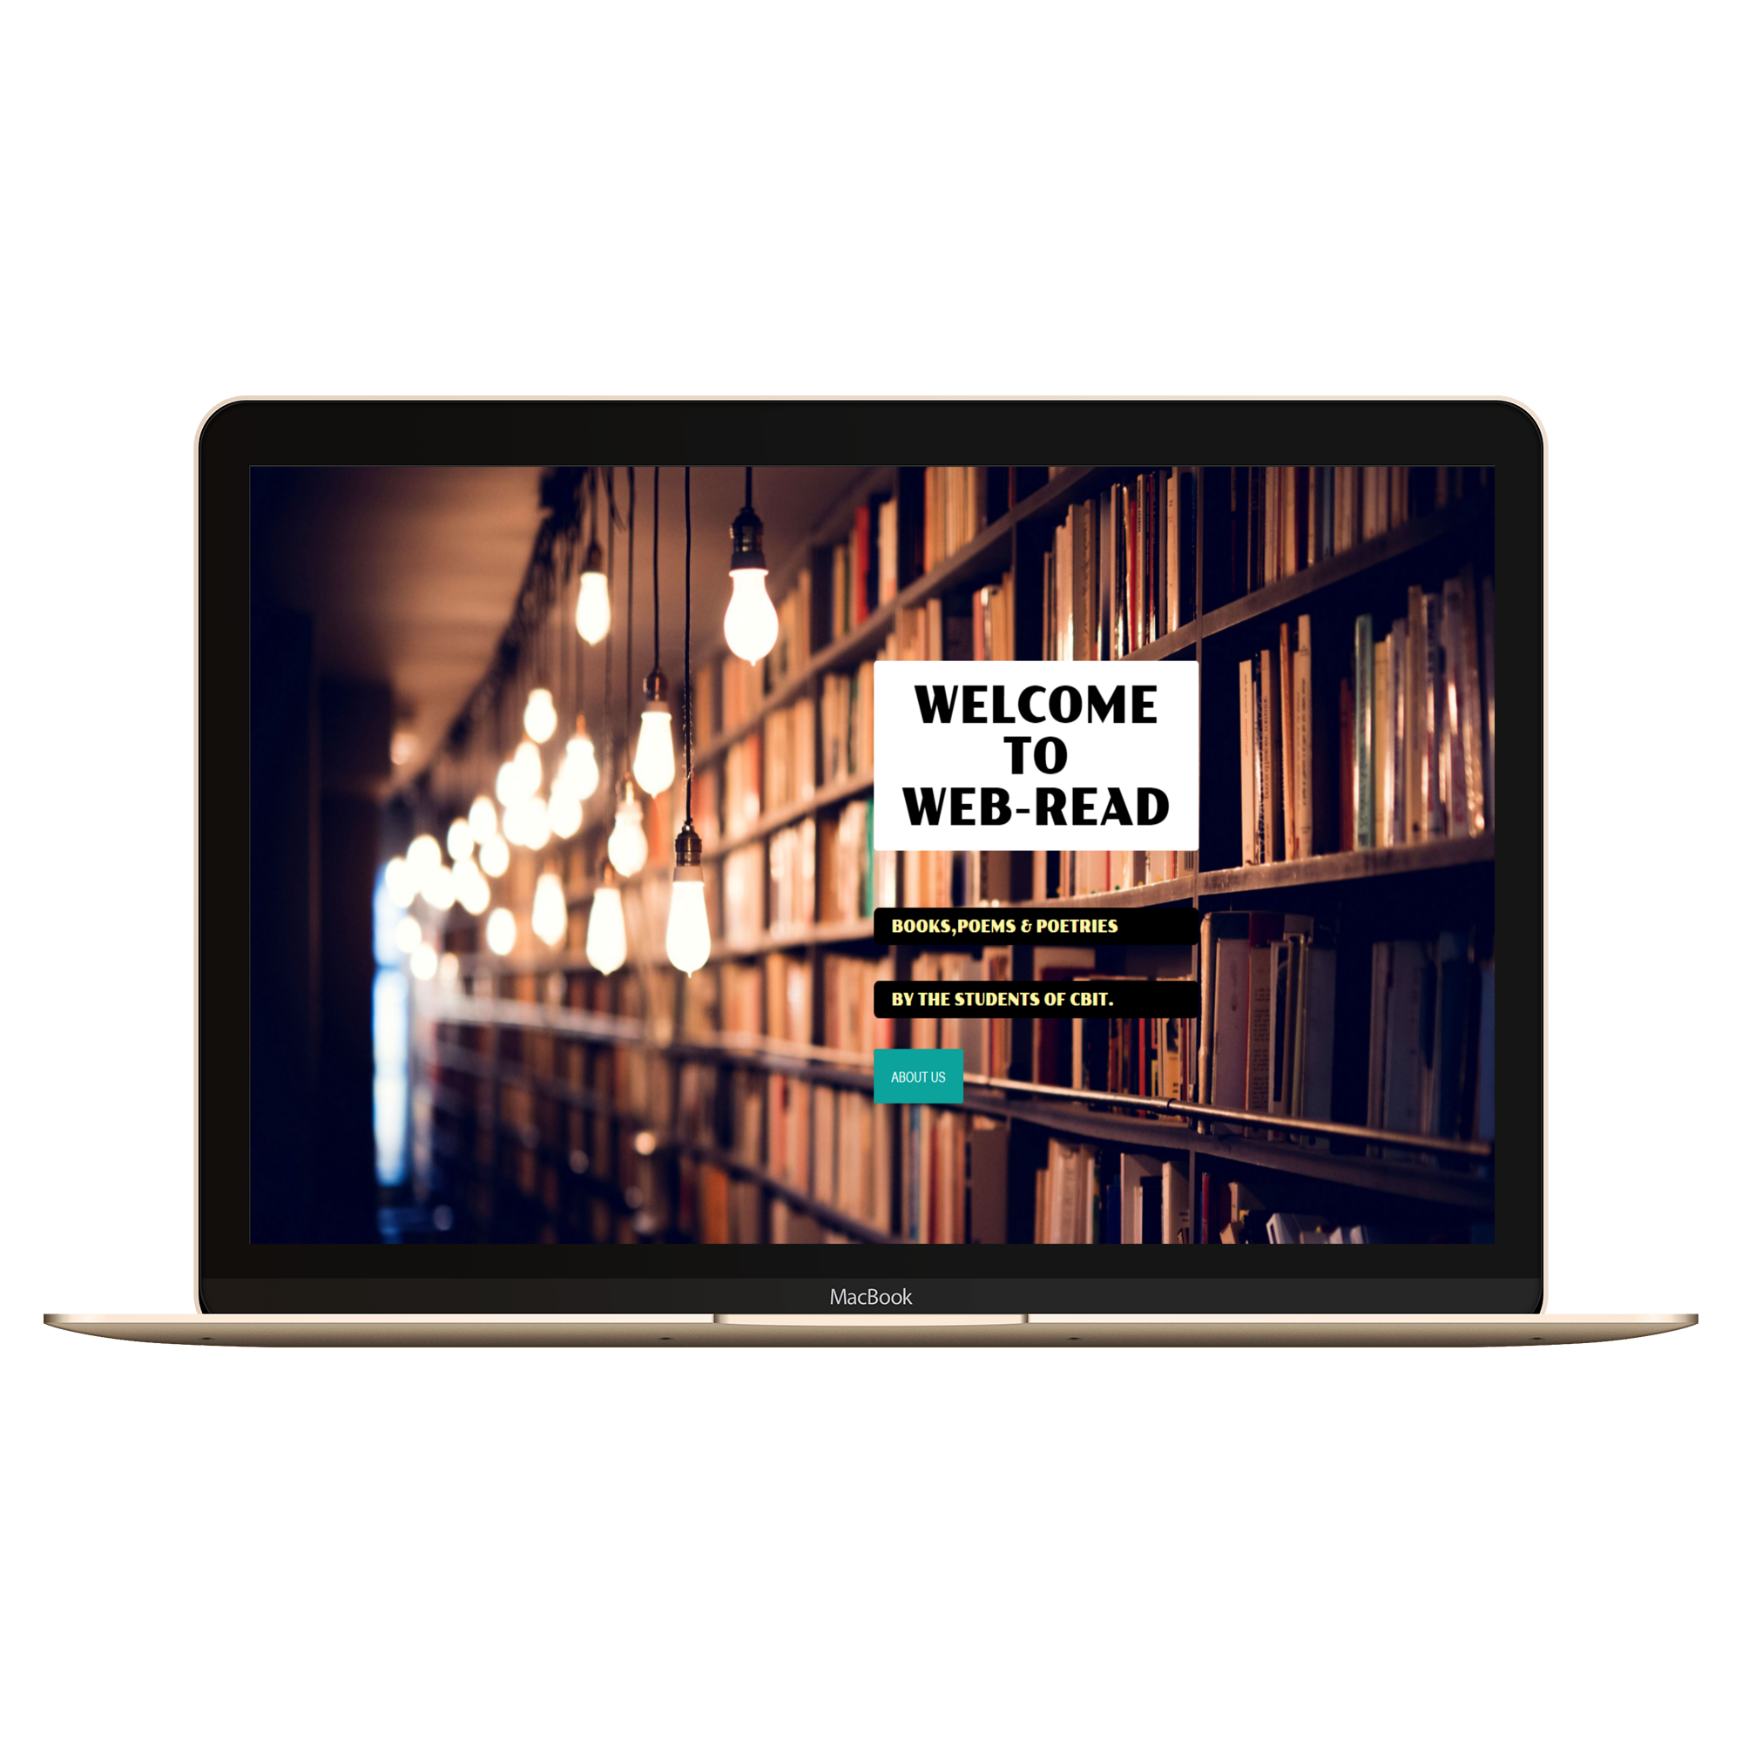

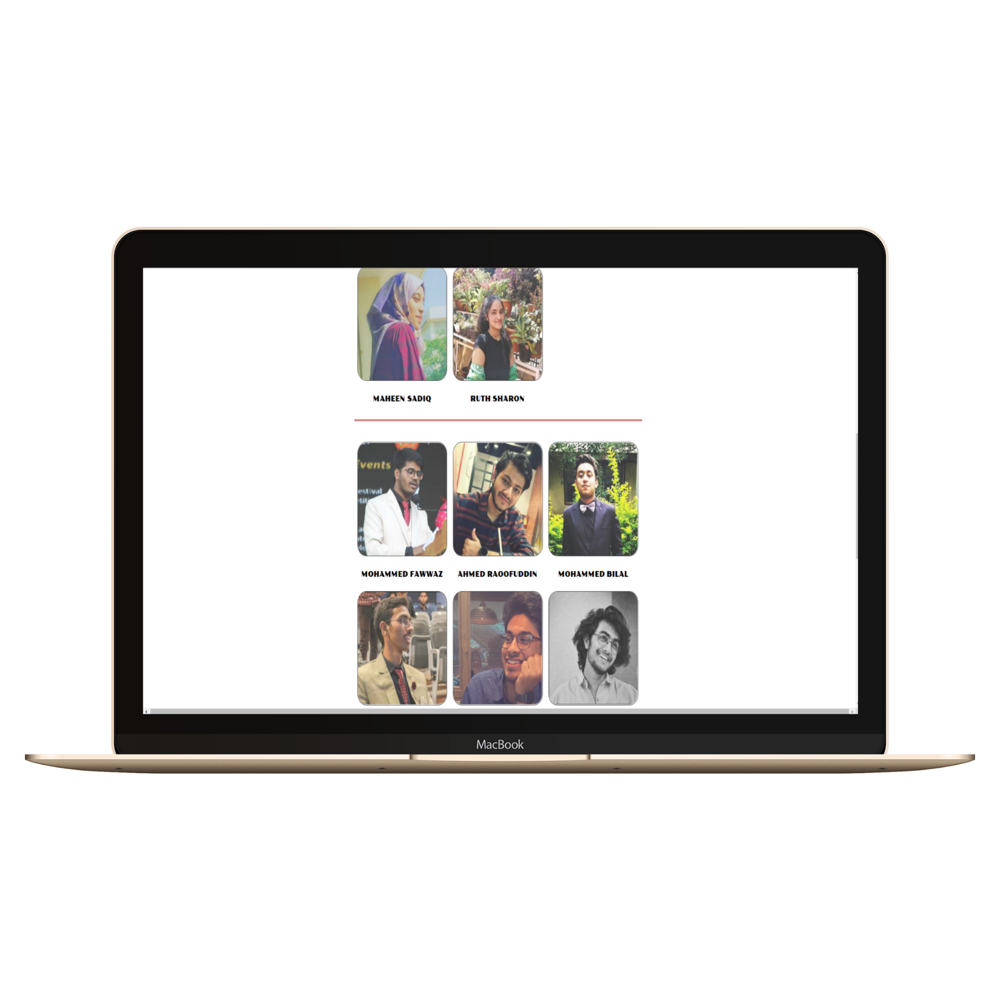

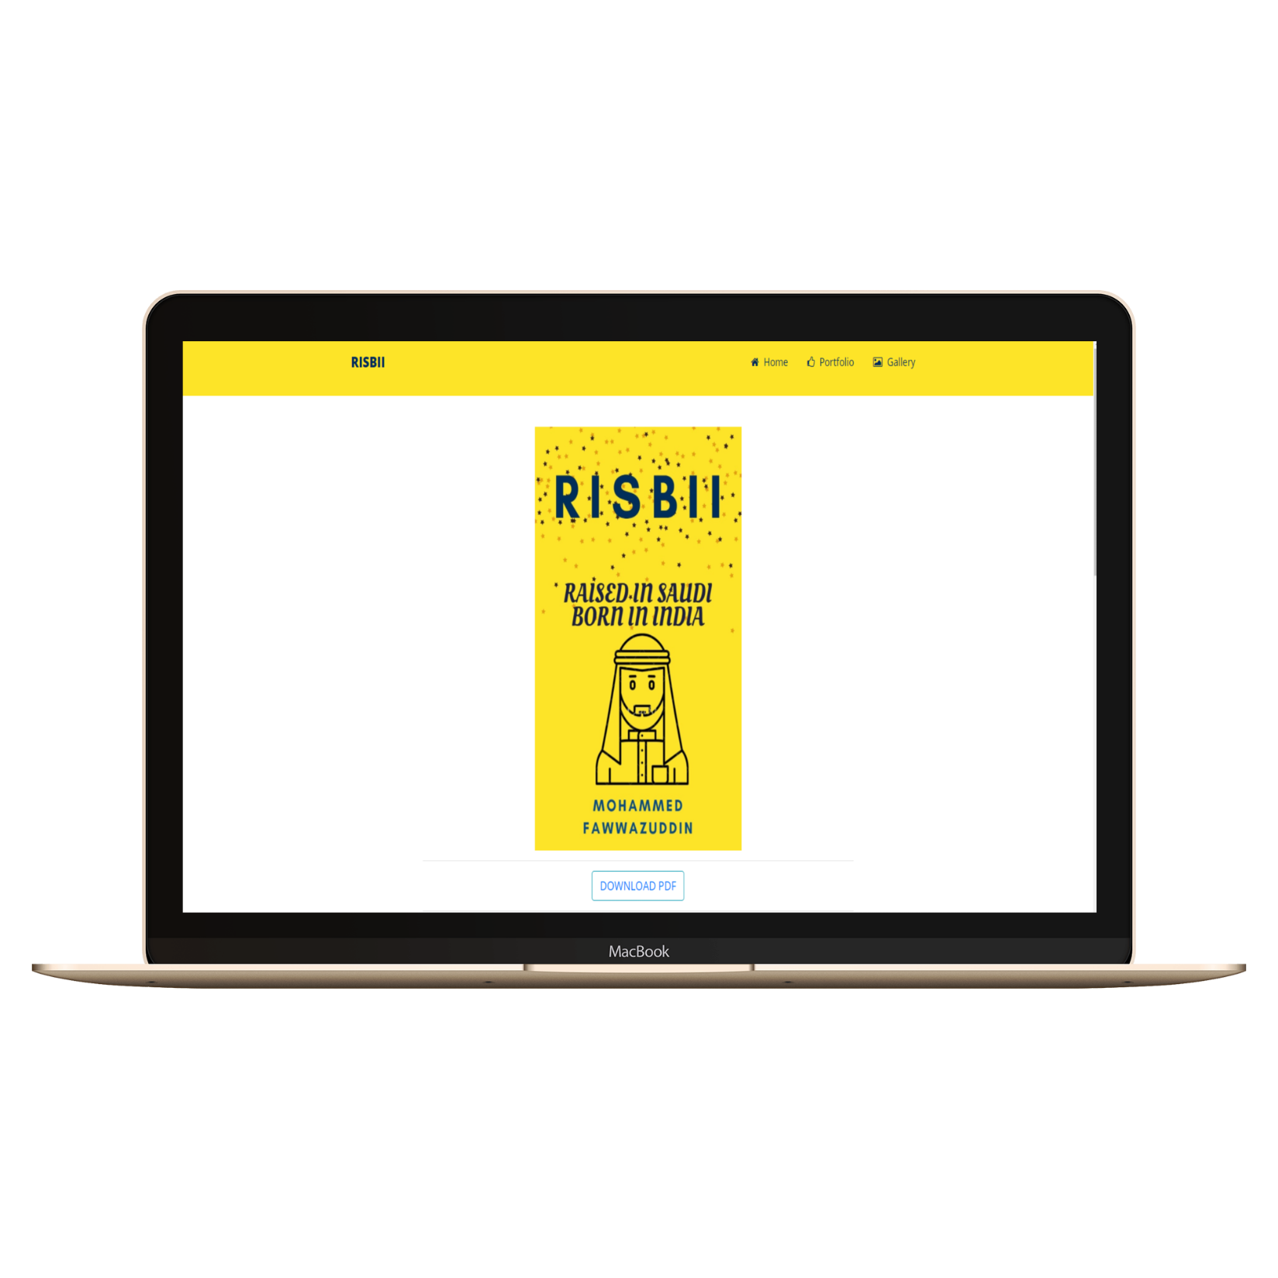

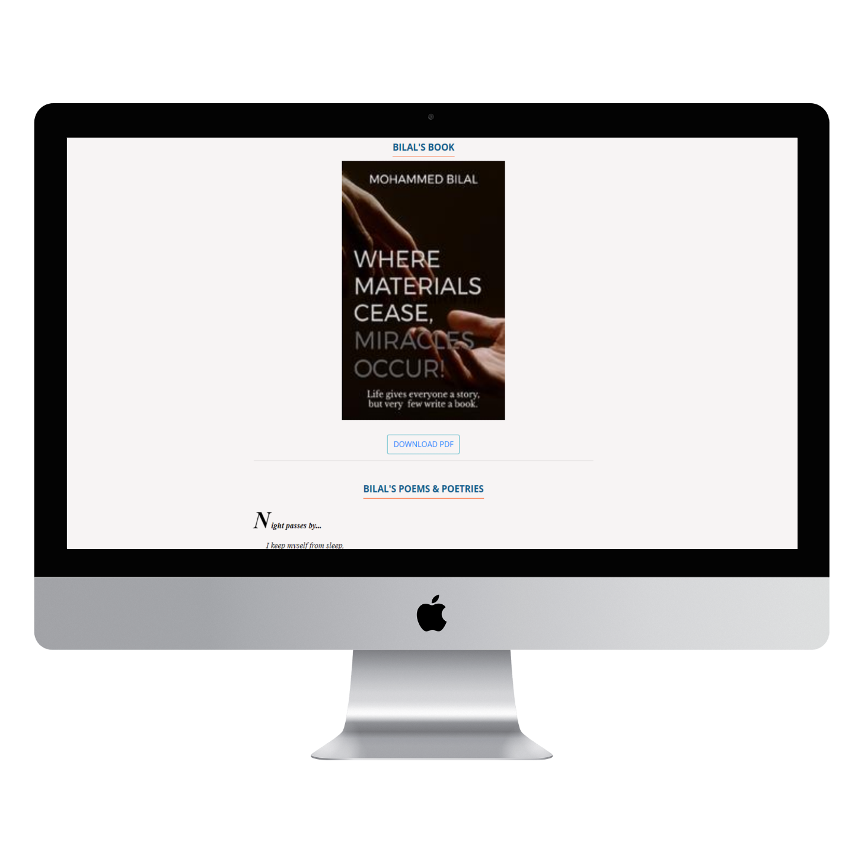

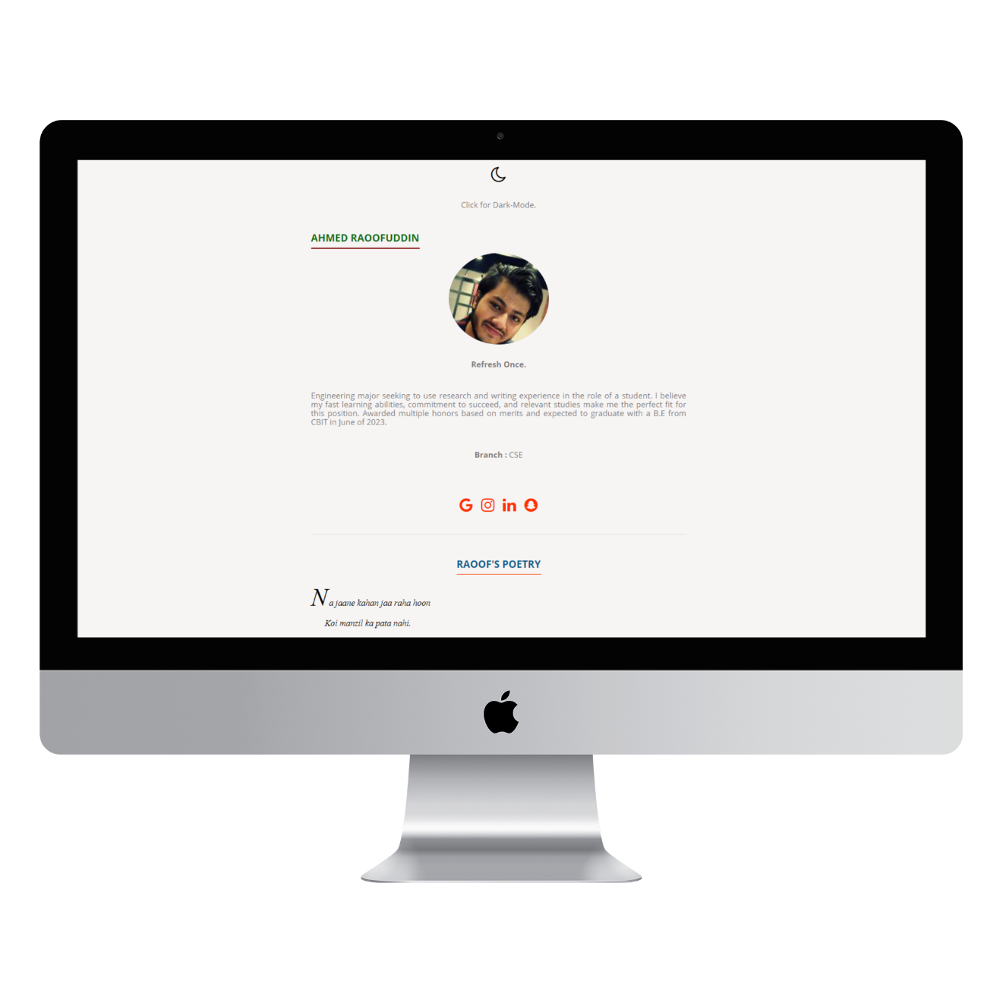

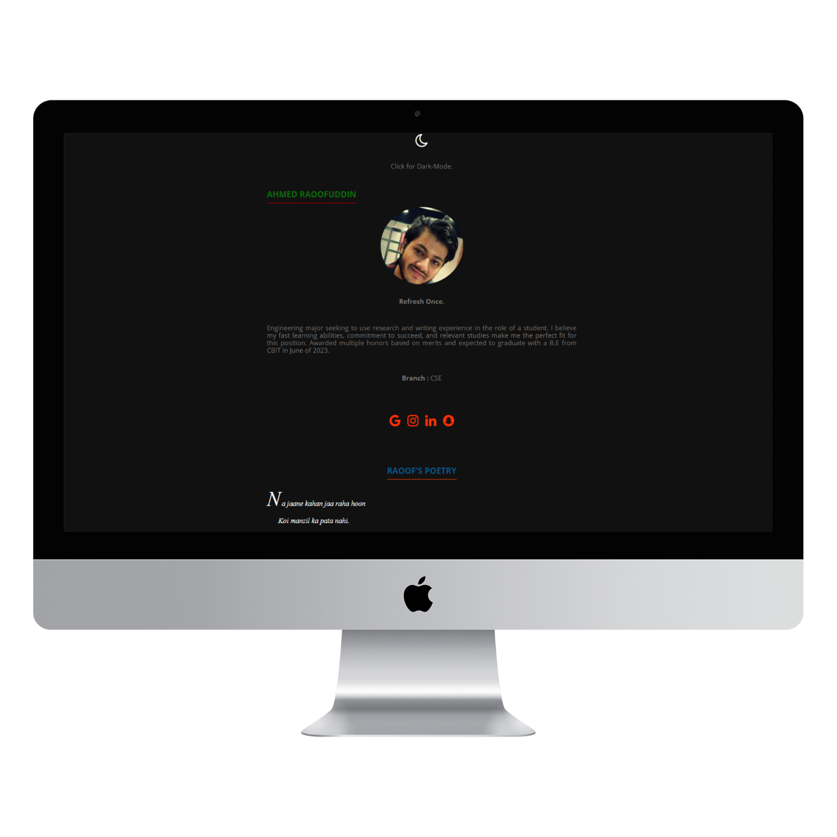

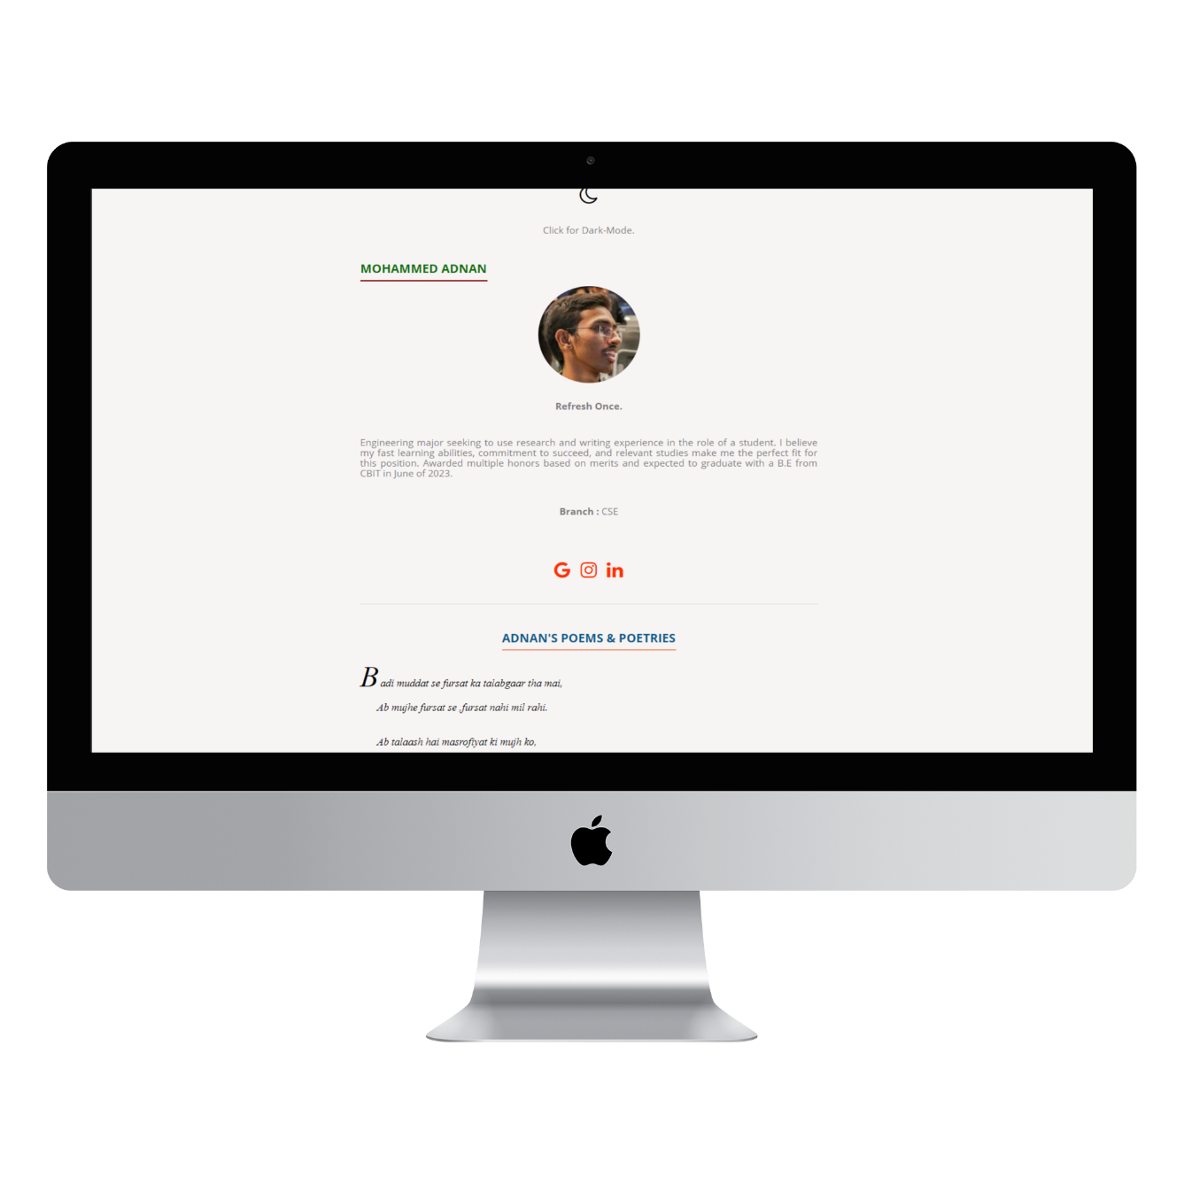

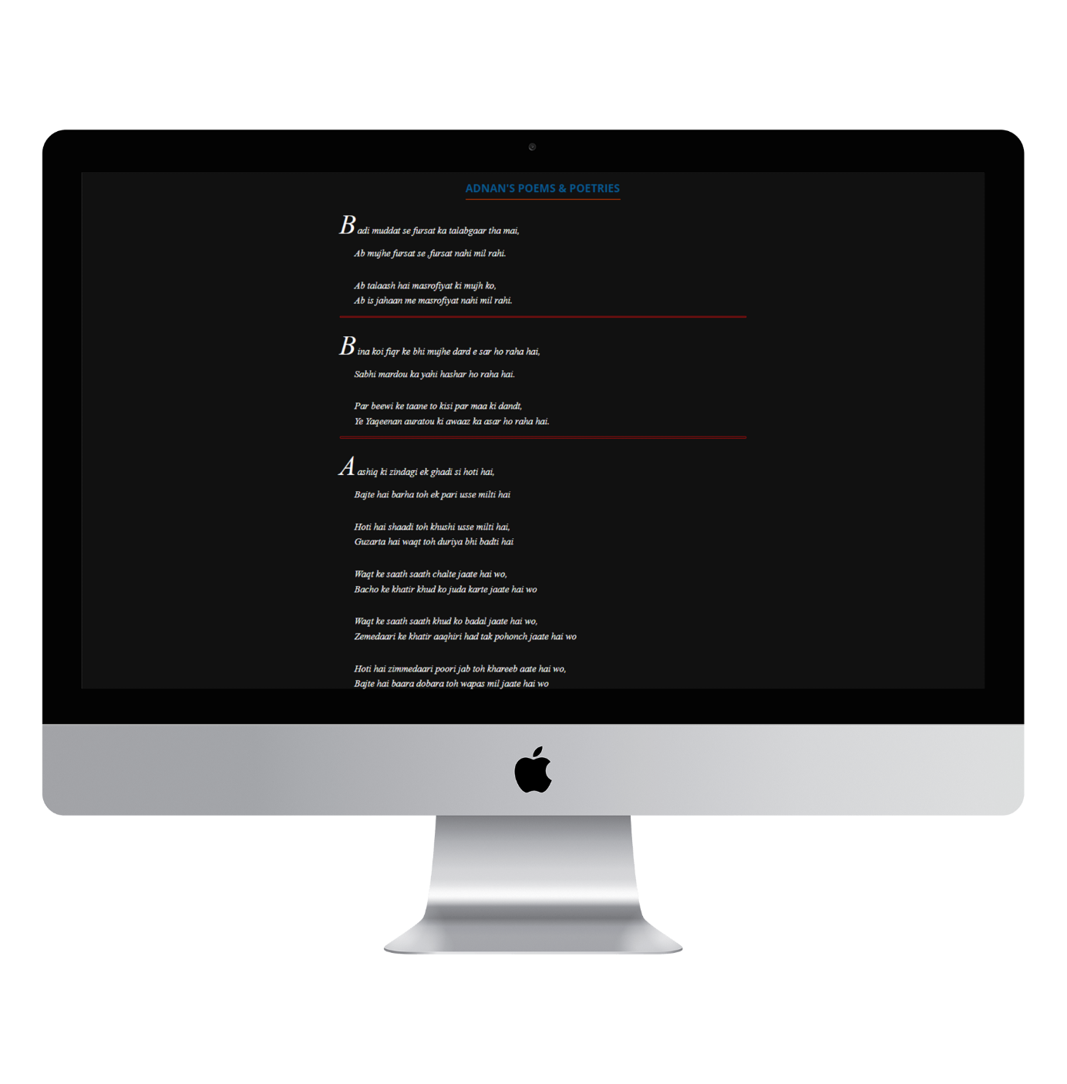

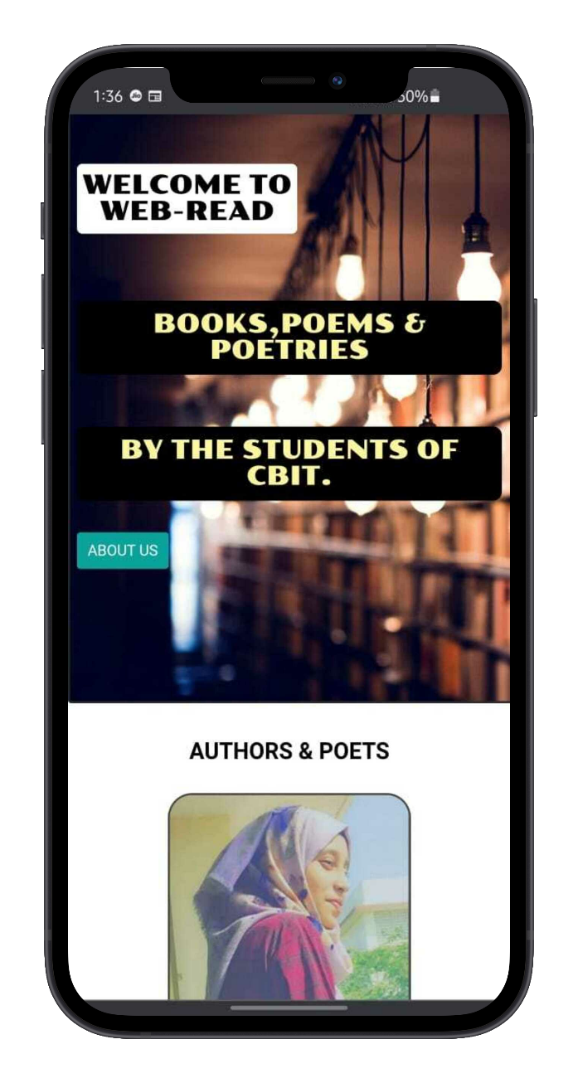

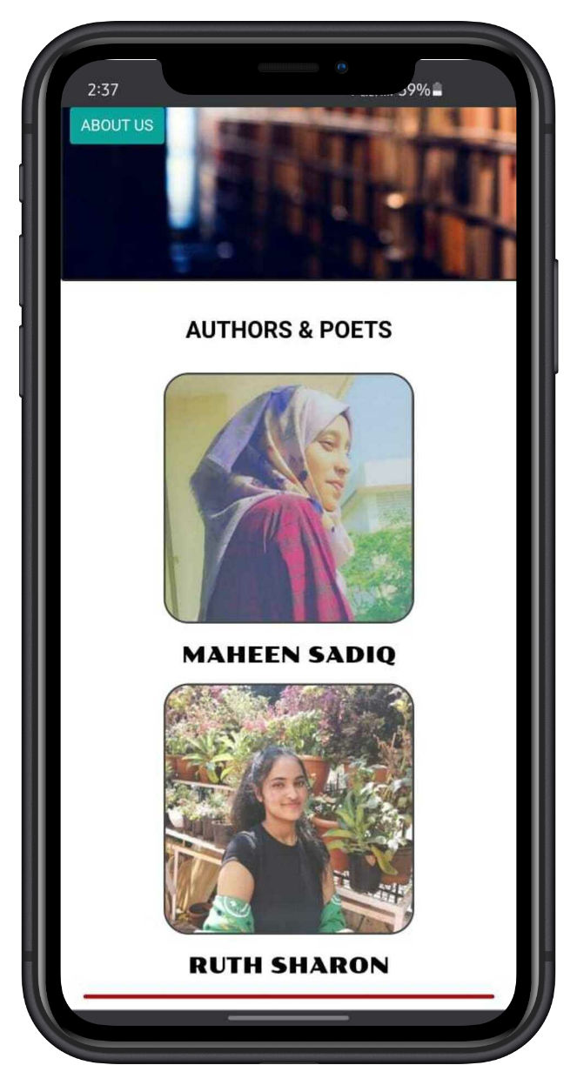

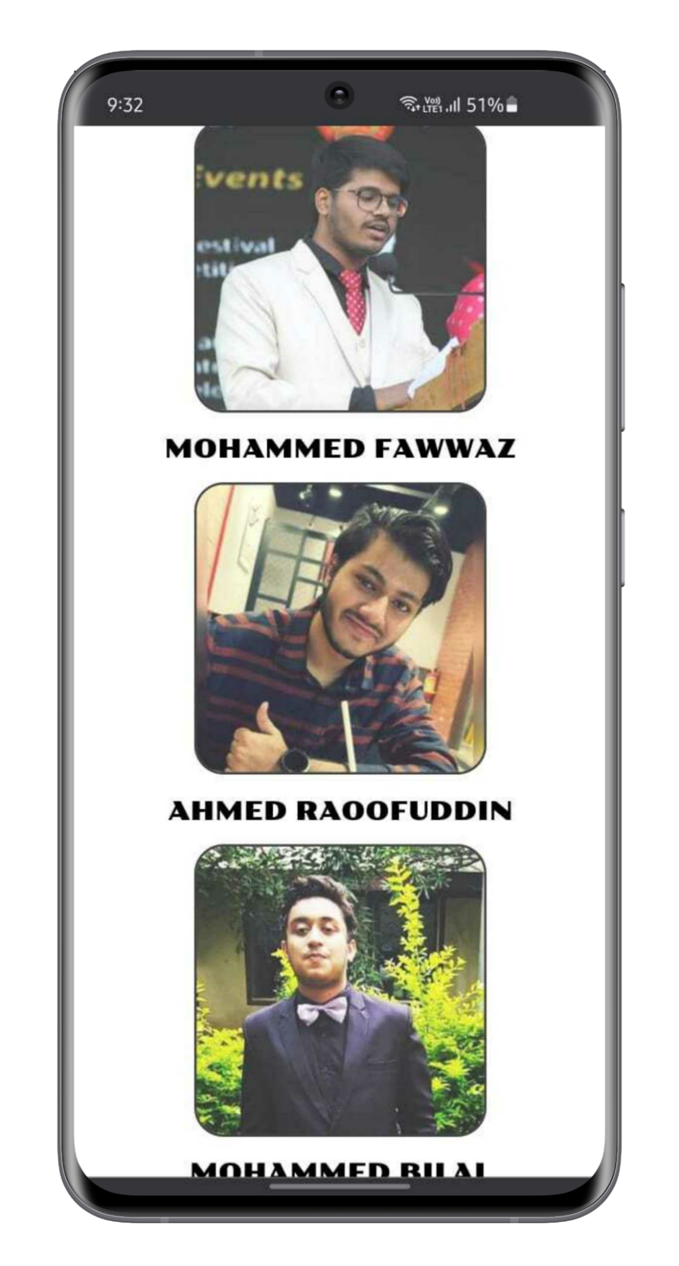

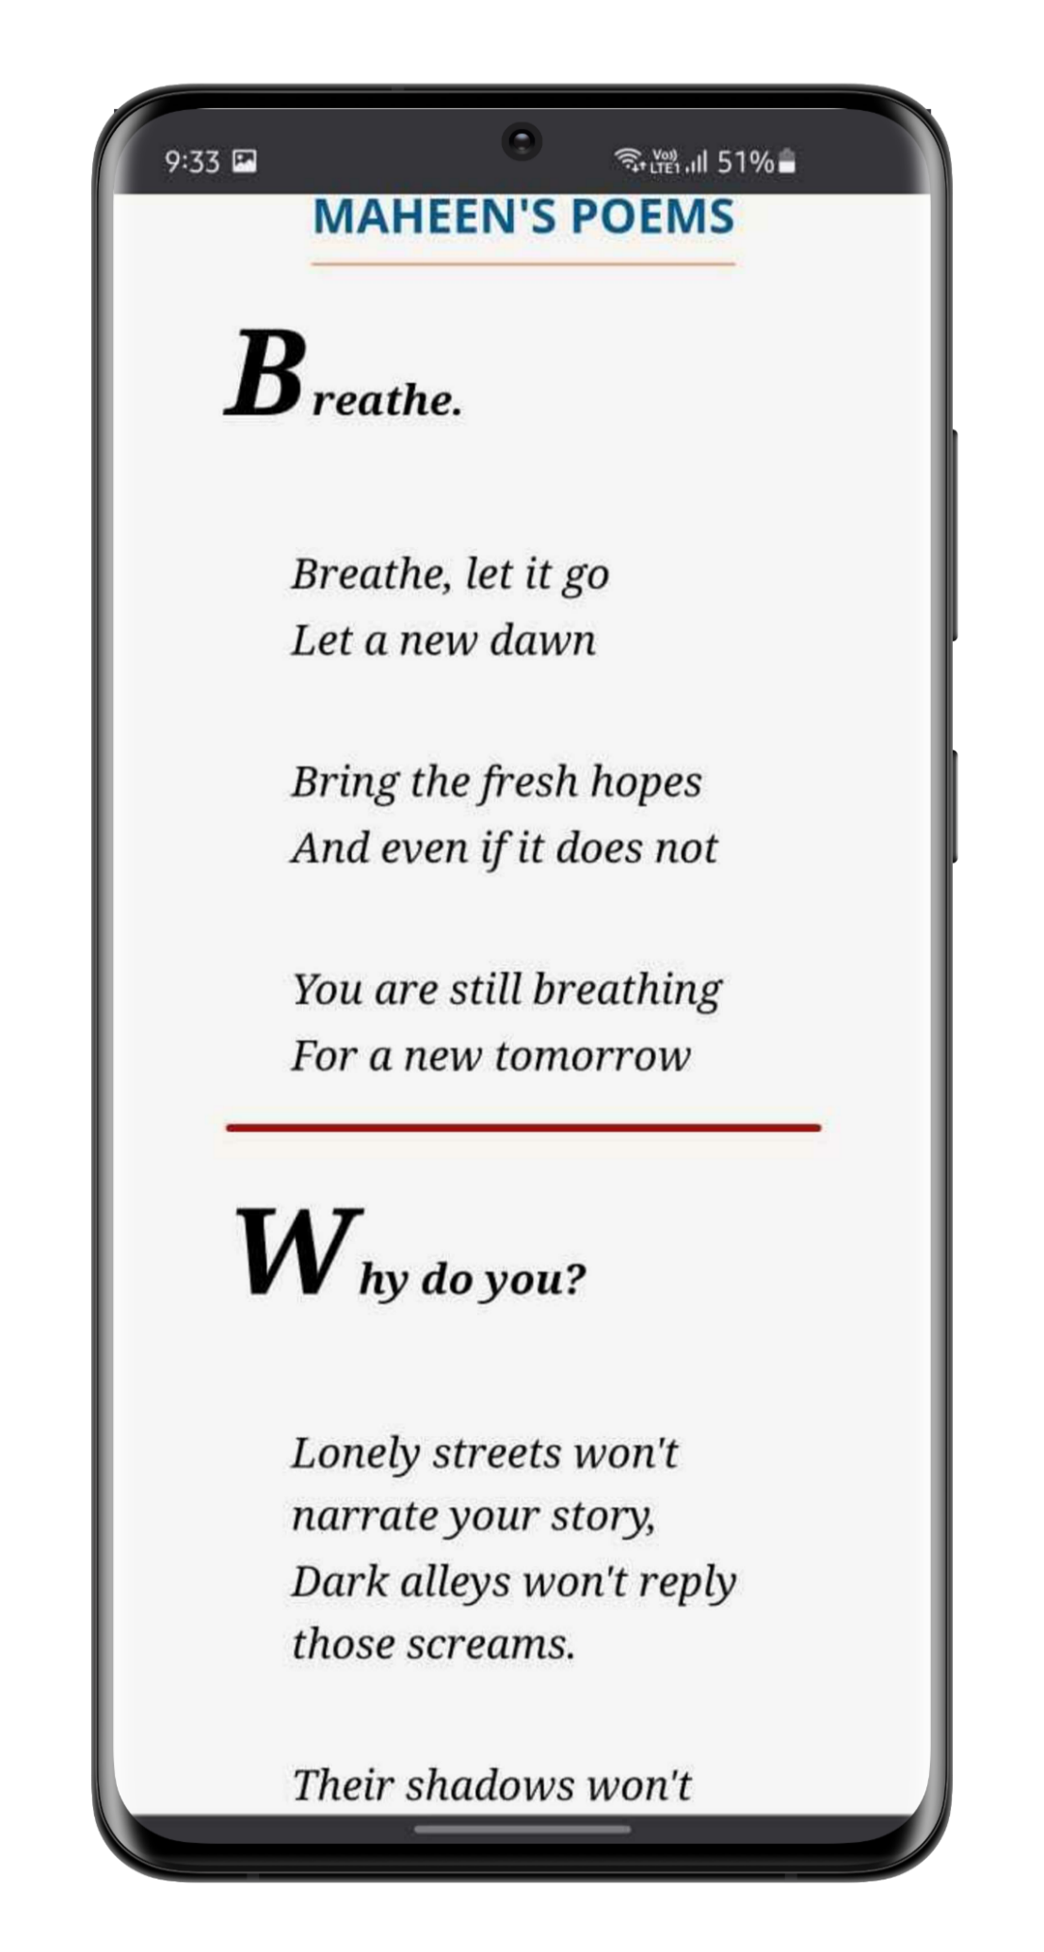

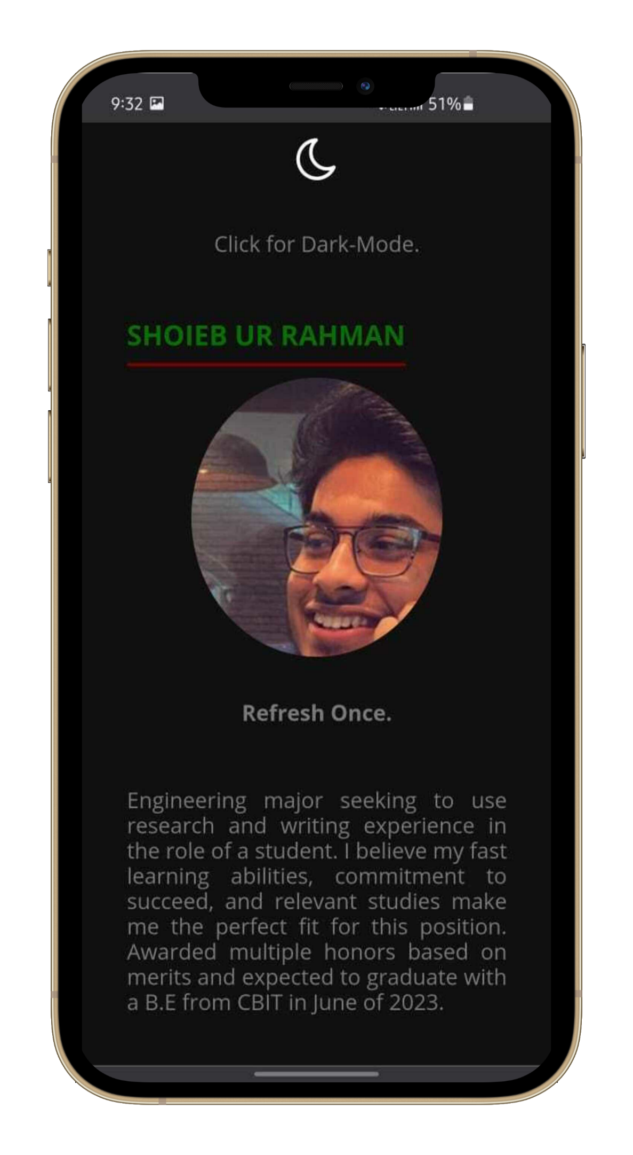

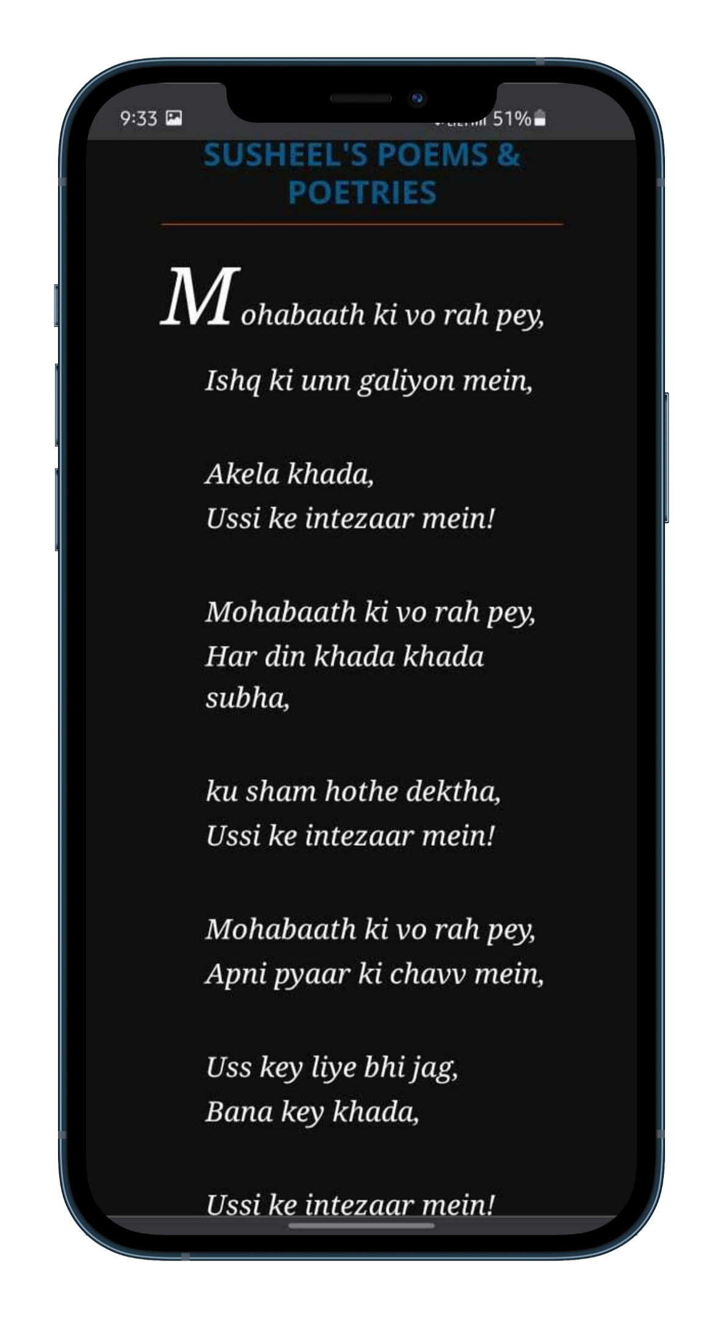

**CONCLUSION**

**- Free access to reading enthusiasts.**

**- Platform to encourage the talents of students across the earth.**

**- Direct access to the social media handles of authors.**

**FUTURE SCOPE**

**- Run completely by A.I.**

**- Faster Load of webpages using Advanced JavaScript.**

**- Additional Add-ons.**

**- New and improved Database for data inventory.**

**BIBLIOGRAPHY**

## HTML & CSS: Design and Build Web Sites, Book by Jon Duckett.

[**https://web-read.netlify.app/**](https://web-read.netlify.app/)

## <https://www.netlify.com/>

[**https://getform.io/**](https://getform.io/)

[**https://mockuphone.com/**](https://mockuphone.com/)